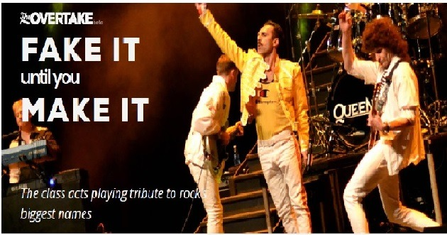

Lauren John
The Overtake (National Independent News Site)
June 5th 2019

Tribute bands get a tough go of it. So often the words “tribute act” are proceeded by the word “bad”. They can be trapped in the shadow of the musicians they imitate, unfavourably compared and derided as unoriginal. While modern orchestras are applauded for covering pieces written hundreds of years ago, the worlds of pop and rock are not cutting the same slack.

The Beatles are widely credited for inspiring the tribute band trend and it’s something that’s never gone out of fashion as an ever-growing number of acts attempt to emulate iconic bands and meet audience demand for nostalgia and classic hits. Among the good, the bad and the ugly are some truly class acts who go the extra distance to recreate something memorable, skilled and respected by fans and the original bands alike.

“To poo-pooh it, as some sort of throwaway genre that doesn’t merit a bit of respect, is surely a ridiculous proposition.” Who’s Who vocalist, Gary O’Donnell tells The Overtake.

The Who tribute act, Who’s Who, arrived on the scene in 1996 when Brit Pop was big and skilled players on the London scene were seeking alternatives to chasing record deals in a climate where they didn’t quite fit. As lead singer O’Donnell comments: “Certainly this band came out of the remnants of one or two London live circuit pro or semi-pro bands. Now there seem to be more tribute acts than original acts; everybody thinks they can do it, which really isn’t the case.”

But this four-piece obviously can do it, and do it well; having journeyed from their formation at the Railway Hotel in Harrow, to their 2016 20th anniversary celebrations at the Hammersmith Apollo, both former haunts of their famous counterparts. According to O’Donnell, “There’s always an anniversary in tribute land.”

With a back catalogue that includes acclaimed rock operas and plenty of hits like My Generation and Pinball Wizard, there’s always a wide choice for their setlists. O’Donnell comments they “pick all the ‘big’ songs, then fill in the gaps with album tracks that have developed cult status. The Who were an album band anyway, so that isn’t too diﬃcult to put together.”

Fairly easy setlist decisions follow an even easier decision to channel the classic line up of The Who, including the late Keith Moon and John Entwistle, rather than the current touring band. “We have a drummer that plays and looks like Keith Moon, and though the rest of us aren’t lookalikes, we don’t feel it would be authentic for him to be playing on You Better You Bet, for example. There was a spirit there when John and Keith were alive and playing. And while that’s still there in the spirit of the music today, it doesn’t necessarily evoke the same sound, which can only point to one thing – chemistry!”

Although the band point to a rising number of The Who tributes increasing competition, the opportunities are still there and with that all important chemistry and musical knowledge, maybe one day their anniversary celebration will be equalling the playing years of the original band — only 32 years to go.

Opportunities for UK tributes haven’t gone unnoticed in Europe. Italian-born Claudio Desideri has been embracing life as the frontman of Flash, a Queen tribute act, since 2016. It’s easy to see why Desideri was tempted. “The shows are bigger and better in the UK than in Italy and are far more frequent. We started with around 30 shows and now this year it looks close to 130 plus. The opportunities have been amazing.”

Flash are undoubtedly riding on the crest of a Bohemian Rhapsody biopic wave right now but renewed interest in Queen is only half the story. They were cementing their reputation well before Rami Malek’s voluminous wigs and fake teeth hit the big screen.

The Flash story began in 2002, but it’s from 2016 onwards — when Desideri and guitarist Nathan Mathers joined the band– that sparks started to fly. They brought the vital chemistry that Flash has in unlimited supply. Their mix of charisma, boundless energy, and musical talent is a formidable combination. For Flash, however, it isn’t just musical skill that has made them into an atom bomb about to oh, oh, oh, oh, oh explode. The detail is vital too.

Everything from the drum kit and bass amp to the replica Red Special guitar is identical to those used on the Magic Tour. And it doesn’t end there, from their trainers to the mannerisms you see on stage, everything is a part fitting the Flash jigsaw. That commitment to authenticity does come with some drawbacks though, and escaping Queen can be diﬃcult.

“Without doubt, it’s the vocals and the harmonies. The actual playing of the instruments becomes somewhat second nature,” says the band. “Even when we fool around playing someone else’s song, it usually ends up sounding like a Queen-inspired song.”

Life on the road has taken the band up, down and across the UK countless times, into Europe and even Dubai. This year they’ll also be playing at the Oﬃcial International Queen Fan Club Convention for the first time. But the band is quick to point out that behind the scenes it’s far from glamorous. “It’s very, very long days. The 8hr a day drive, 3hr set–up and pack down, and the waiting around is the hardest part to deal with.”

Their set list has won praise for its variety, its inclusion of album versions and the sheer emotion when they reprise hits like These Are The Days Of Our Lives. Of course, Bohemian Rhapsody inevitably makes its way onto the setlist in one way or another. “We often do bits of it during sound checks, but as Queen did, we always use the track for the opera section, it makes for a bigger bang when we return.”

Making a statement on stage is something The Fillers have had to do from day one, albeit with a more limited budget than the Las Vegas superstars they emulate. But their attention to detail, as they try to keep up with The Killers high impact, flamboyant stage shows, has not gone unnoticed. Lead vocalist Trevor Hurley is ever grateful for the attention they were given. ”The Killers noticed us right back in the beginning, and since then have just been gracious. They would mention us in interviews, I’ve even ended up opening for them across the world in an original band. No one in any of the tributes I know has had that sort of access.”

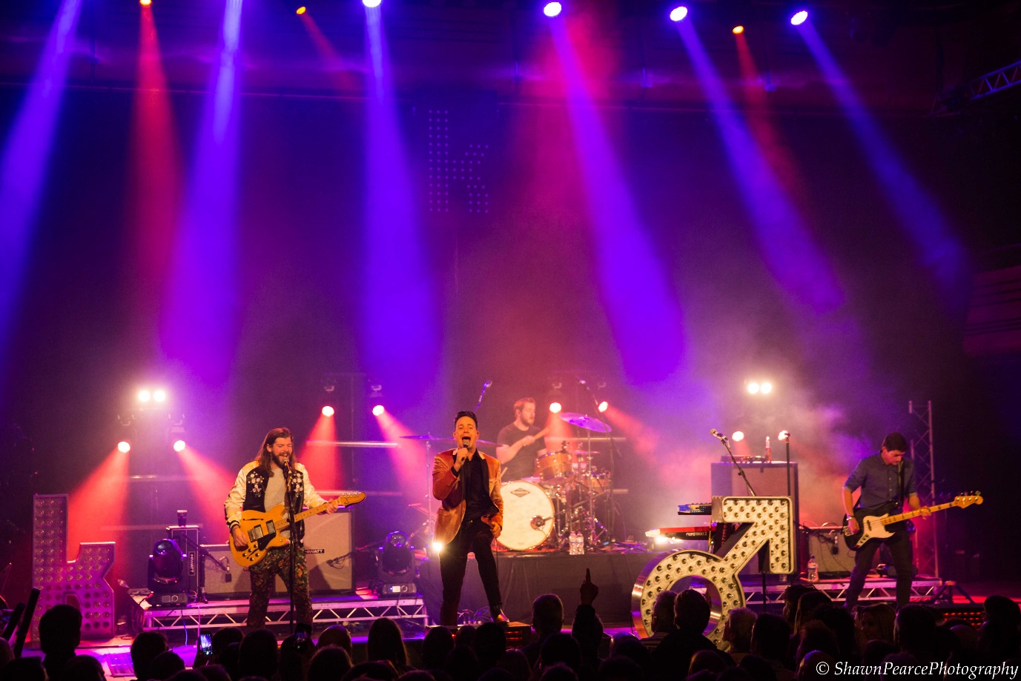

Each of these tribute bands spoke about recreating an authentic a sound, but with the original band is very much still here — touring and releasing new material– Hurley and his bandmates have to keep on their toes. “We have tried to keep in step with what The Killers do. When they are promoting an album, we will tend to play as much of the new material as they do. That has a cycle of about 8 months, then you see they cherry pick the songs that have been a hit live, and blend those with the core set list.”

The Fillers have taken their stage show, which features tracks from Hot Fuss to Wonderful Wonderful, from their hometown of Bury St Edmunds across the UK festival circuit and beyond. Their strong web presence has been a great advantage for the band and they’ve had the chance to play USA, Mexico, The United Arab Emirates, Holland and more.

That international acclaim has been great for the band. Trevor speaks of a memorable moment when “we played a party where the drummer from The Killers showed up and kicked our drummer off the kit and played with us”.

“That was pretty funny and scary.”

There’s never a dull moment in tribute band land and organiser of tribute festival GlastonBARRY Matt Blumberg argues if you give a tribute festival a try, you might just be surprised. “I think people turn up expecting a tongue in cheek festival, where some of the bands are going to be a bit naff, but then they are blown away by the standard. We spend a lot of time researching bands, and only go for the best on the circuit.”
GlastonBARRY has grown from a capacity of 500 people to over 6,000 this year. Other festivals are celebrating birthdays in double figures and more and more events are popping up across the country; a sign that tribute festivals, and the bands they put on, are in demand and here to stay.

